EXP 5 for 2 bit ALU
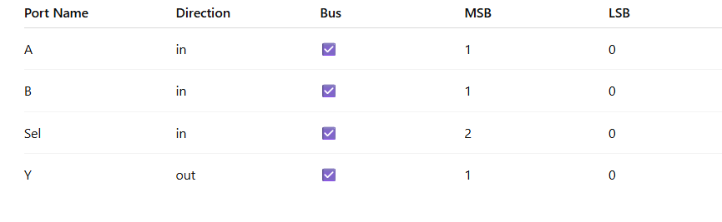
library IEEE;
use IEEE.STD_LOGIC_1164.ALL;
use IEEE.NUMERIC_STD.ALL;

entity alu_8bit is
Port (
A : in STD_LOGIC_VECTOR (1 downto 0);
B : in STD_LOGIC_VECTOR (1 downto 0);
Sel : in STD_LOGIC_VECTOR (2 downto 0);
Y : out STD_LOGIC_VECTOR (1 downto 0)
);
end alu_8bit;

architecture Behavioral of alu_8bit is
begin

process(A, B, Sel)
begin
case Sel is
when "000" => Y <= std_logic_vector(unsigned(A) + unsigned(B));
when "001" => Y <= std_logic_vector(unsigned(A) - unsigned(B));
when "010" => Y <= A AND B;
when "011" => Y <= A NAND B;
when "100" => Y <= A XOR B;
when "101" => Y <= A XNOR B;
when "110" => Y <= A OR B;
when "111" => Y <= A;
when others => Y <= (others => '0');
end case;
end process;

end Behavioral;
Testbench Code

LIBRARY ieee;
USE ieee.std_logic_1164.ALL;
USE ieee.numeric_std.ALL;

ENTITY alu_tb IS
END alu_tb;

ARCHITECTURE behavior OF alu_tb IS

-- Component Declaration
COMPONENT alu_8bit
PORT(
A : IN std_logic_vector(1 downto 0);
B : IN std_logic_vector(1 downto 0);
Sel : IN std_logic_vector(2 downto 0);
Y : OUT std_logic_vector(1 downto 0)
);
END COMPONENT;

-- Inputs
signal A : std_logic_vector(1 downto 0) := (others => '0');
signal B : std_logic_vector(1 downto 0) := (others => '0');
signal Sel : std_logic_vector(2 downto 0) := (others => '0');

-- Output
signal Y : std_logic_vector(1 downto 0);

BEGIN

-- UUT
uut: alu_8bit PORT MAP (
A => A,
B => B,
Sel => Sel,
Y => Y
);

PROCESS
BEGIN

-- Test values (valid 2-bit)
A <= "10";
B <= "01";

Sel <= "000"; wait for 20 ns; -- ADD
Sel <= "001"; wait for 20 ns; -- SUB
Sel <= "010"; wait for 20 ns; -- AND
Sel <= "011"; wait for 20 ns; -- NAND
Sel <= "100"; wait for 20 ns; -- XOR
Sel <= "101"; wait for 20 ns; -- XNOR
Sel <= "110"; wait for 20 ns; -- OR
Sel <= "111"; wait for 20 ns; -- PASS A

wait;

END PROCESS;

END;

Implementation Code
library IEEE;
use IEEE.STD_LOGIC_1164.ALL;
use IEEE.NUMERIC_STD.ALL;

entity Expt_1b is
Port (
A : in STD_LOGIC_VECTOR(1 downto 0);
B : in STD_LOGIC_VECTOR(1 downto 0);
sel : in STD_LOGIC_VECTOR(2 downto 0);
Y : out STD_LOGIC_VECTOR(1 downto 0)
);
end Expt_1b;

architecture Behavioral of Expt_1b is
begin

process(A, B, sel)
begin
case sel is
when "000" => Y <= std_logic_vector(unsigned(A) + unsigned(B));
when "001" => Y <= std_logic_vector(unsigned(A) - unsigned(B));
when "010" => Y <= A AND B;
when "011" => Y <= A NAND B;
when "100" => Y <= A XOR B;
when "101" => Y <= A XNOR B;
when "110" => Y <= A OR B;
when "111" => Y <= A;
when others => Y <= (others => '0');
end case;
end process;

end Behavioral;

Implementation Constraint file
NET "A<0>" LOC = "A10" | IOSTANDARD = LVCMOS33;
NET "A<1>" LOC = "D14" | IOSTANDARD = LVCMOS33;

NET "B<0>" LOC = "C14" | IOSTANDARD = LVCMOS33;
NET "B<1>" LOC = "P15" | IOSTANDARD = LVCMOS33;

NET "sel<0>" LOC = "P12" | IOSTANDARD = LVCMOS33;
NET "sel<1>" LOC = "R5" | IOSTANDARD = LVCMOS33;
NET "sel<2>" LOC = "T5" | IOSTANDARD = LVCMOS33;

NET "Y<0>" LOC = "U18" | IOSTANDARD = LVCMOS33;
NET "Y<1>" LOC = "M14" | IOSTANDARD = LVCMOS33;

